MY PET
Poslušaj posnetek (lahko tudi večkrat). Razporedi ljubljenčke v pravilen vrstni red (Number:…, po vrsti tako, kot jih slišiš na posnetku). Pobarvaj ljubljenčke. Dopolni povedi (1. What pet is it? 2. What colour is it? 3. What's its name?).
Number: 1  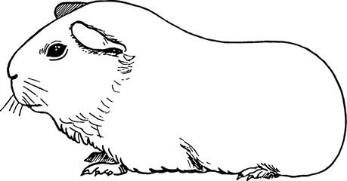  1. I've got a guinea pig.  2. It's brown and white.  3. Its name is Poli. | Number:  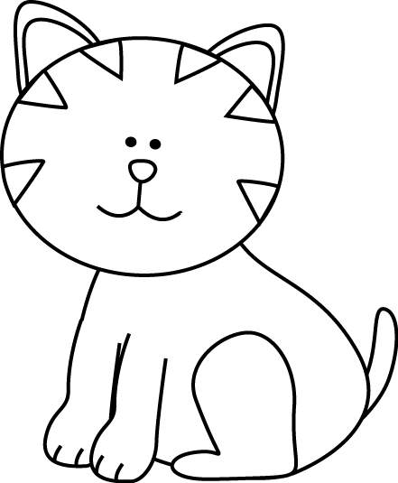  1. I've got a _____________.  2. It's ______________.  3. Its name is ____________. | Number:  1. I've got a _____________.  2. It's ______________.  3. Its name is ____________.
Number:  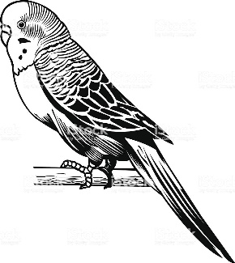  1. I've got a _____________.  2. It's ______________.  3. Its name is ____________. | Number:  1. I've got a _____________.  2. It's ______________.  3. Its name is ____________. | Number:  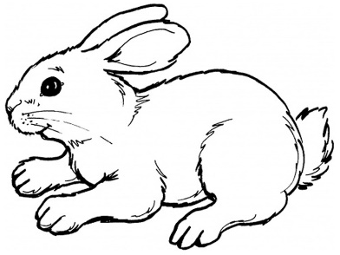  1. I've got a _____________.  2. It's ______________.  3. Its name is ____________.

