DAYS OF THE WEEK
M | Z | R | E | S | T | A | X | E | S
O | N | Q | I | V | H | L | K | A | E
U | N | S | A | T | U | R | D | A | Y
E | M | A | I | U | R | S | O | N | S
W | E | D | N | E | S | D | A | Y | U
F | T | P | O | S | D | Y | D | Z | N
T | M | O | N | D | A | Y | A | R | D
F | R | I | D | A | Y | P | X | E | A
Y | E | O | S | Y | S | U | I | R | Y
- Obkroži dneve v tednu.

- . What day was it yesterday? What day will it be tomorrow? Kateri dan je bil včeraj? Kateri dan bo jutri?
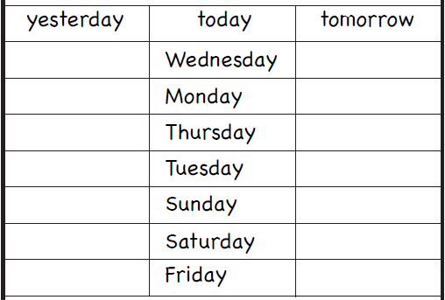

- Unscramble the words. Razvozlaj besede.
