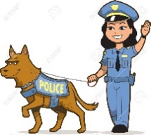
OCCUPATIONS - POKLICI

- Add these words to the text: v besedilo vstavi naslednje besede iz okvirčka
hat, help, police, bus, nature, shop assistant, actor, cook, photographer, television, cafe, police officer, waiter, bus driver

I spend a lot of time on the road. I drive people to different places.
I drive a ____________. I am a ___________________________________.

I wear white clothes and a white ____________. I work in the kitchen.
I prepare a lot of delicious food there. I am a ______________.

I play in the films. You can see me on the ___________________. I play many different roles.
I am an _______________________.

I work in a shop. I _______________ people choose different things.
I am a _______________________________.

I work in a _______________. I make coffee and serve other drinks.
I am a ____________________.

I work at the ___________________ station. I help people and wear a blue uniform.
I am a ______________________________________.

I always have my camera with me. I spend a lot of time in the __________________.
I am a ________________________.

